New Product Highlight

**Like an Ice Cooler, Insolcorp’s Thermatile Ceiling Tiles Regulate Temperatures to Save Energy, Costs**

As part of our stewardship mission to our clients, we’re always on the lookout for technologies, products and services that help make them more efficient or successful. iSi gets involved in construction and renovation projects, from the initial environmental survey of the property before its purchased, in the design phase, during renovation, or at the end to help a company get their safety and environmental programs in place. As a result, a product from Insolcorp that uses thermal storage ceiling tiles to capitalize on the waste heat above your dropped ceiling tiles has caught our attention.

Suspended acoustical ceilings and exposed roof decks can be challenging to HVAC systems in commercial buildings. Often that space is just filled with ductwork and wiring, or it’s used for HVAC air flow. In addition to that, additional heat is generated from windows, people, equipment, lighting, other sources. That creates a lot of waste heat that lives in commercial buildings during the wintertime, and a lot of this same heat works against the cooling system in the summer. For that reason, Insolcorp developed its Thermatile ceiling tiles and Infinite-R blanket solutions.

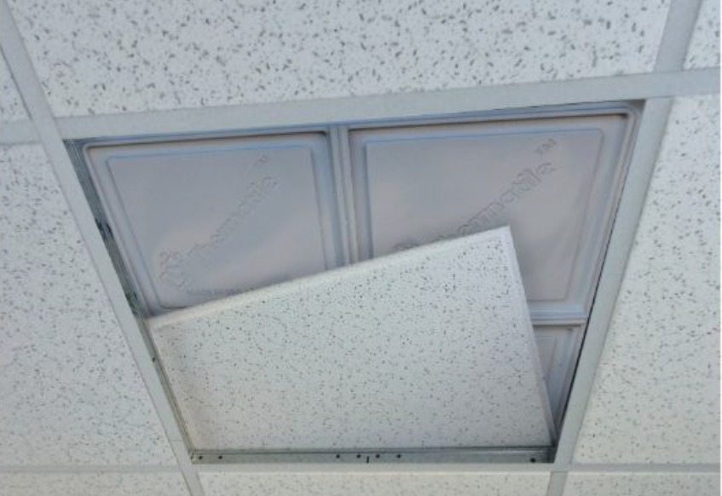The products are made of phase change materials (PCM) that absorb and naturally release thermal heat within your building. Just like an ice cooler (such as a Yeti brand cooler), the PCM built into the panels melt to absorb heat (solid to liquid/gel) and then when they solidify, they release that heat (liquid/gel to solid). The panels naturally absorb heat or air conditioning during the day and then release that heat at night.

Thermatiles can be laid over the top of existing ceiling tiles or used in place of the tiles themselves. Infinite-R blankets can be laid into walls or ceiling framing, or used to fill exposed walls or roof decks.

Insolcorp’s studies of more than 50 clients in 7 climate zones has shown that facilities using these products are saving 20-30% on HVAC costs on the average. When used for comfort control, studies show they have reduced temperature swings by more than 50% and dropped facility service calls.

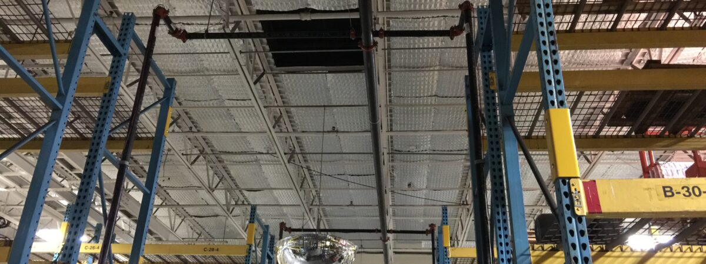Insolcorp has installed these materials in offices, hospitals, an Olympic training facility, and manufacturing facilities. At one client’s manufacturing facility, the facility was having trouble with high temperatures in manufacturing buildings, and air conditioning wasn’t feasible in those locations. Daily temperature fluctuations caused increases in worker heat stress, affecting not only worker comfort but the actual amount of units they were producing. The heat was also causing issues in storage areas where extreme temperatures were ruining the products themselves, creating more loss. Insolcorp installed 221,000sf of PCM mats to the underside of the facility’s existing metal roof deck. As a result,

* Factory peak temperature was reduced more than 20° F;
* 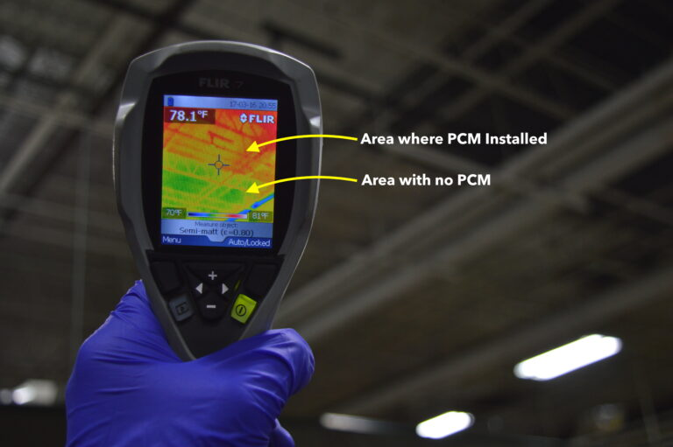Factory production levels now remain consistent throughout the year with no increase in operating expense (HVAC or maintenance);
* Dramatic improvement in worker heat stress, comfort and productivity; and,
* The improvements were significant enough for the company to have the same phase changing materials installed in other factory locations.

For more information about these PCM materials, or to start a discussion about using an Insolcorp PCM product at your facility, [check out this page](https://isienvironmental.com/energy-efficient-ceiling/), or [contact us here](https://forms.zoho.com/isienvironmental/form/ThermalTile).